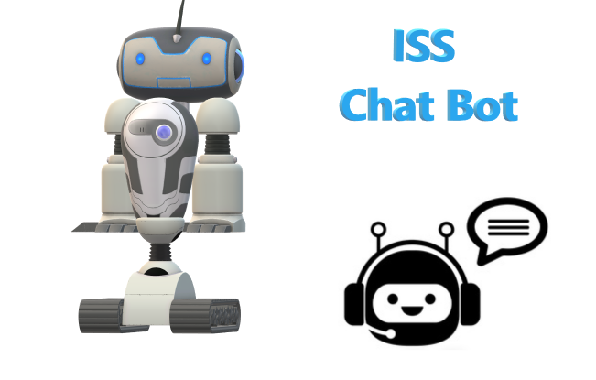

**ISS ChatBot**

|  |
| --- |
|  |

**User’s Manual**

**REQUIREMENTS:**

**RECOMMENDED BROWSERS**

ISS ChatBot uses the DialogFlow in-built user interface and the interface was embedded into a webpage:

* Google Chrome Version 64 and above

**SYSTEM OVERVIEW**

ISS Chatbot is a smart conversational agent that is knowledgeable about the courses taught at the Institute of Systems Science (ISS). We developed the ISS Chatbot using Google DialogFlow as a natural language understanding engine to understand the text messages of the users.

When a user inputs a text message, the Chatbot processes the message to determine what is the intent behind the message. Our Chatbot can determine a user’s intent because we have trained it by providing example phases of how a user searching for information on ISS courses would ask their questions. After determining the intent, the Chatbot may request for more information from the user if this information was not provided in the text message.

When the Chatbot has obtained all the required information, it will either display a default message to the user, or the Chatbot will send a POST request of the identified intent and its parameters to a Python Flask web server application using the webhook function of DialogFlow.

When the Python server receives the request from Chatbot, it will identify the appropriate response to return to DialogFlow to display to the user. We also use the database function of DialogFlow to serve as a back-up in case the Python server was unable to process the request.

**USER INTERFACE**

Our backend runs as a Python Flask web application. The web interface is a conversational platform where the user can interact with our chatbot through text messages.

**DEPLOYMENT**

Method 1 (running from the cloud)

Download the file “iss_autobot_agent.html” into the local computer folder from <https://github.com/francis-han/Dialogflow-Project/blob/master/SourceCodes/ISS-AutoBot.zip>. Open “iss_autobot_agent.html” using the Chrome browser. The user can now converse with Chatbot using text messages.

You can inspect our DialogFlow agent by importing the zip file ISS-AutoBot.zip to DialogFlow

Method 2 (In case Method 1 is not working-run from local server)

Login to your DialogFlow account and import the zip file as follow:

1. Click on the gear icon settings next to the agent name in the left menu.
2. Click on the **Export and Import** tab.
3. Click **IMPORT FROM ZIP**.
4. Navigate to and open the ZIP file you want to import.
5. Type "IMPORT" into the text field to confirm.
6. Click **IMPORT**.

Open a console command prompt and go to the folder with the ngrok executable file. For Window, type “ngrok.exe http 5000”. Configure the DialogFlow webhook using the ngrok URL assigned to you (See figure 1).

Figure 1. URL assignment by ngrok

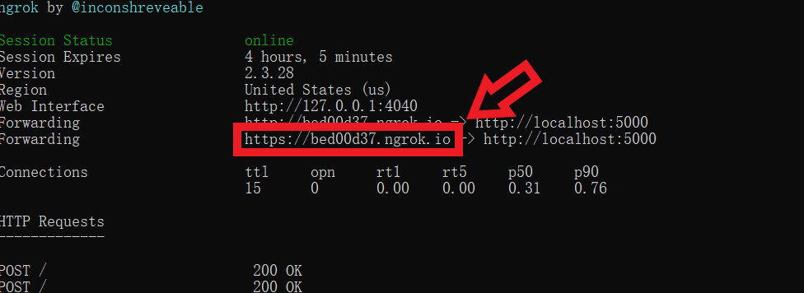

Key in the copied URL into the webhook of DialogFlow (see figure 2).

Figure 2. DialogFlow Webhook

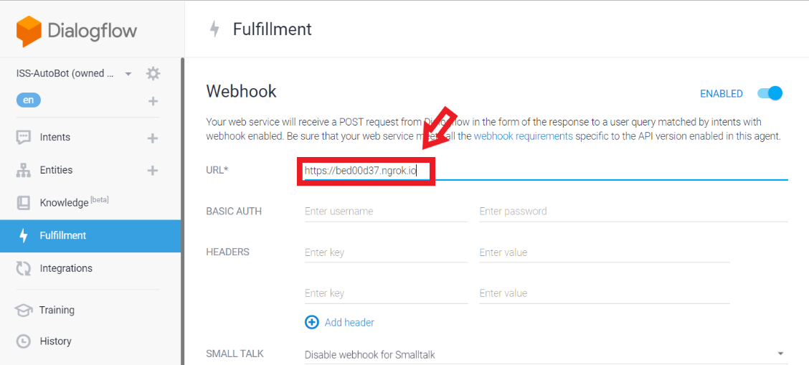

Click on “Integrations” in the left panel of DialogFlow, then click on “Web Demo” (see figure 3)

Figure 3. Integration and Web Demo

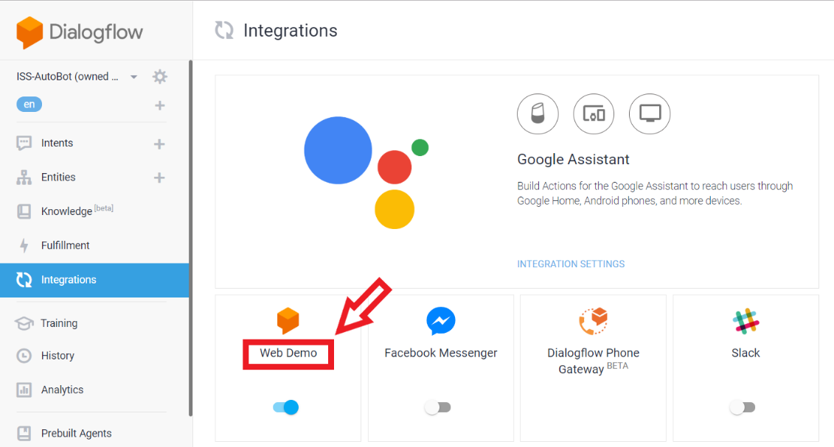

Copy the URL (see figure 4).

Figure 4. HTML agent URL

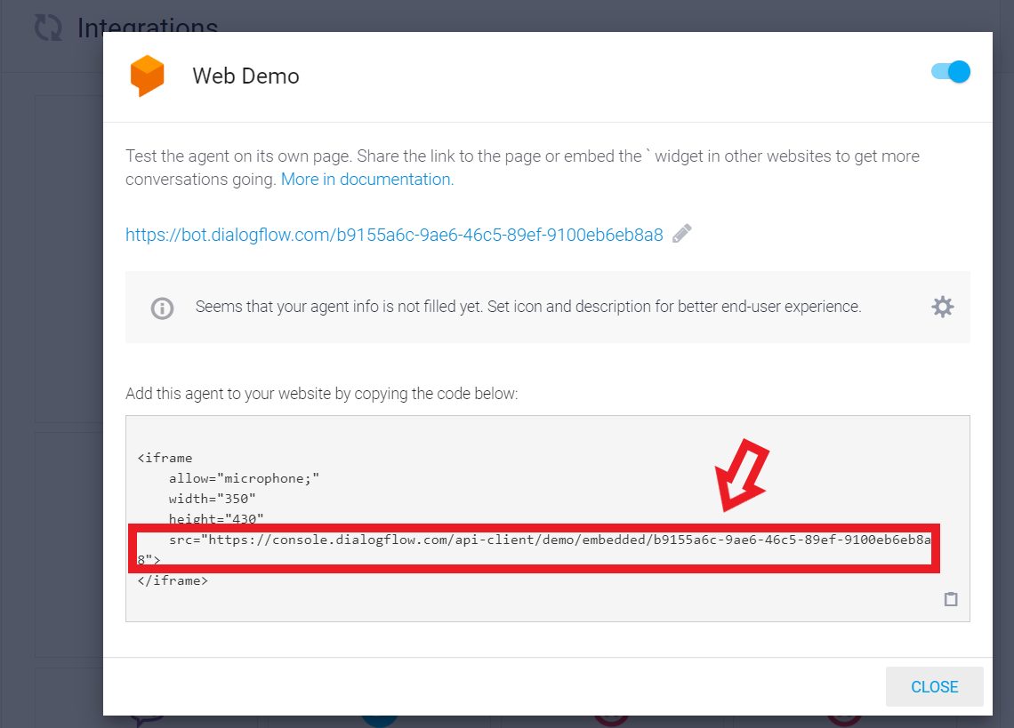

Download the file “iss_autobot_agent.html” into the local computer folder from <https://github.com/francis-han/Dialogflow-Project/blob/master/SourceCodes/ISS-AutoBot.zip>. Change the content HTML URL of “iss_autobot_agent.html” to the one you copied just now (see figure 5).

Figure 5. iss_autobot_agent.html

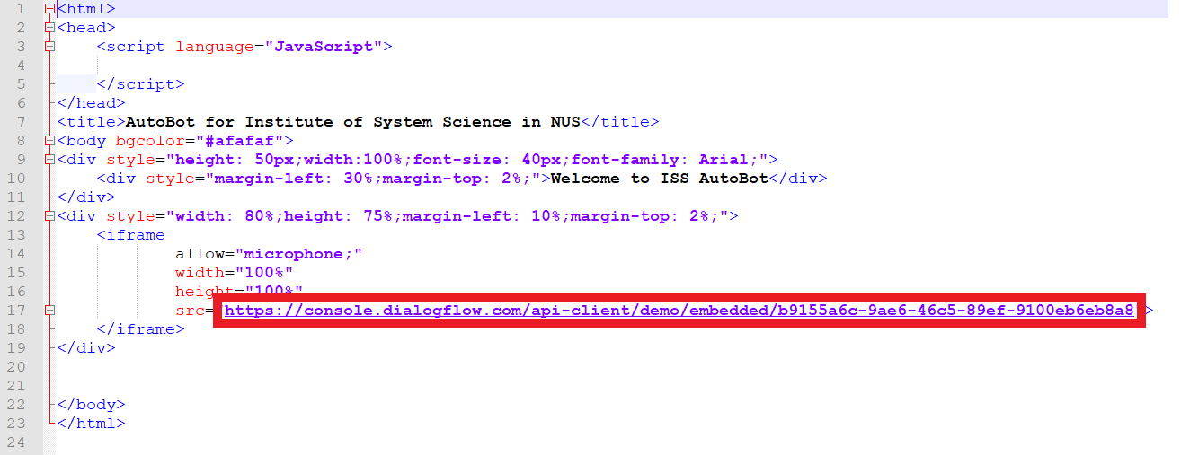

In console command prompt, type in “*py ISSBot.py*” to run the web server. We will be using Google Chrome version 72 (64-bit). Open Chrome browser and go to the URL <http://localhost:5000/>. The user can now converse with Chatbot using text messages.

Conversing with Chatbot

You might like to start the conversation with a greeting and then maybe ask Chatbot question on courses in ISS. Here are a few suggestions: course duration, course fee, and date of next course intake (see figure 6).

You may need to wait a few seconds for a response when you ask the first question.

Figure 6. Conversation between user and Chatbot

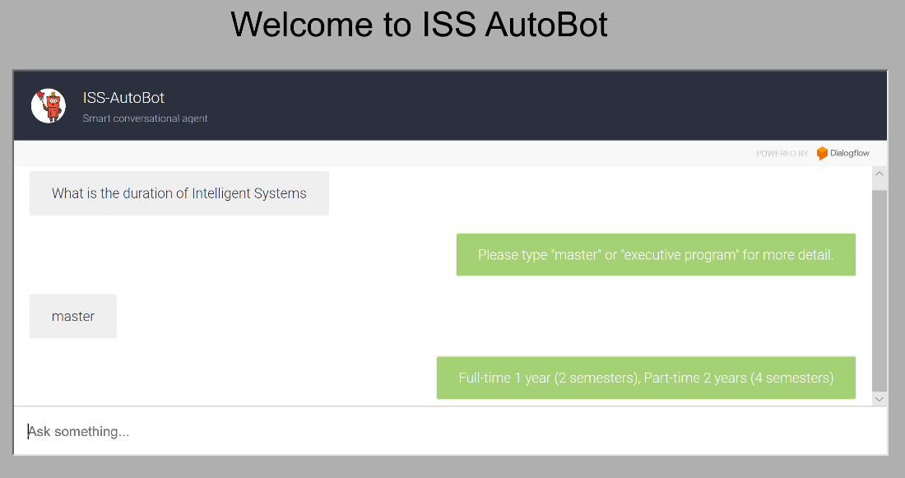

Once you are done with Chatbot, simply type “goodbye” to end the session.